Mobile Data Terminals (MDTs) in Indian Emergency Services
1. Core Functionality & UI
MDTs are ruggedized tablets or in-vehicle computers used by police, fire, and ambulance units ( ERSS 112, UP100).
Tri-Panel Layout:
  - Case List: Shows active incidents with ID, type, and timestamp.
  - Interactive Map: Displays the incident location, real-time vehicle position (GPS), and "Get Path" navigation.
  - Case Details: Lists caller info, priority (color-coded), and subtype (e.g., "Robbery").
Action Keys: Large buttons for Accept/Reject/Complete, camera uploads, and VoIP calls.
2. Key Technology
- CAD Integration: Incidents logged at the Public Safety Answering Point (PSAP) are automatically pushed to the nearest MDT based on GPS proximity.
- Navigation & GIS: Uses MapmyIndia or Google Maps for turn-by-turn routing, including specific "house number" searches and POIs like hydrants or hospitals.
- Bidirectional Communication: Supports text, image, and video chat between field crews and the control room.
- Connectivity: Operates via GPRS/4G with an SMS fallback to ensure reliability in low-network areas.
3. Major Systems & Vendors in India
System/Agency | Technology Provider | Scope/Usage
ERSS (112 India) | C-DAC | Nationwide indigenous platform for police, fire, and rescue.
Dial-100 (MP/UP) | Hexagon & Mahindra | Integrated CAD/MDT system; handles thousands of patrol vehicles.
108 Ambulance | InfoTrack / GVK EMRI | Specialized for medical dispatch, patient tracking, and hospital routing.

- 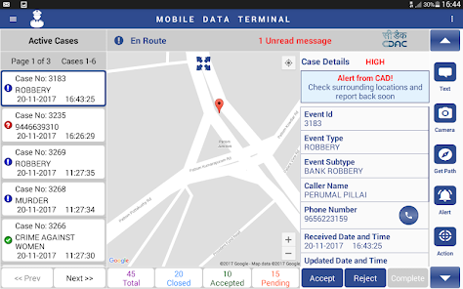
Figure1: Example of an Indian emergency MDT UI. Active incidents are listed on the left; a map with the incident marker in the center; detailed case data (ID, type, caller, etc.) and action buttons (Accept/Reject, text, camera, route) on the right.

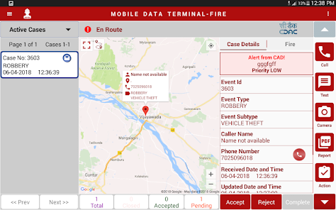
Figure2: Another MDT screen (the “FIRE” app theme). It shows one active case with its map and details. Buttons allow a voice call to the caller, SMS chat, camera for photos, and a “Report” button (likely for incident updates.

India’s PSAP Dashboard Systems
1. System Overview
India is transitioning to a unified 112/ERSS (Emergency Response Support System). This system consolidates various agencies (Police-100, Fire-101, Ambulance-108) into a single technological framework.
- Primary Platform: C-DAC’s ERSS software (indigenous "Total Solution").
- Architecture: A centralized State PSAP (Public Safety Answering Point) linked to District Coordination Centers (DCCs) and field units.

2. Typical Dashboard UI Layout
The dispatcher’s "Single Pane of Glass" is usually a multi-panel interface spanning several monitors:
- Center Panel (GIS Map): The heart of the UI. It displays real-time GPS locations of all emergency vehicles and geocoded incident pins.
- Left Panel (Incident/Caller Info): Pops up automatically when a call lands. Shows Caller ID, phone number, and auto-detected location (via cell tower/GPS).
- Right Panel (Resource Status): A roster of all units (Police, Fire, EMS). Units are color-coded (e.g., Green for Available, Blue for En Route, Red for On Scene).
- Bottom Panel (Event Log): A scrolling list of active cases with status updates (Pending, Dispatched, Closed).

3. Key Functional Modules
Module | Functionality
CAD (Computer-Aided Dispatch) | Logs calls, creates "events," and provides automated unit recommendations based on proximity.
GIS (Mapping) | Integrates road networks and Points of Interest (POIs) like hospitals, police stations, and fire hydrants.
Communication Gateway | Handles multi-channel distress signals: Voice, SMS, Email, Panic SOS, and Web requests.
MDT Integration | Pushes incident data directly to the Mobile Data Terminal (Tablet) in the rescue vehicle.

4. Operational Workflow
- Intake: A call taker receives the signal; the system geolocates the caller on the map.
- Verification: The incident is classified (e.g. "Medical Emergency") and an SOP is generated.
- Dispatch: The dispatcher identifies the nearest available unit on the map and "pushes" the case to their MDT.
- Monitoring: The dispatcher tracks the unit’s travel in real-time. Communication (chat/VoIP) is recorded in the case log.
- Resolution: Once the field unit marks the task as "Complete," the dashboard updates, and the unit returns to "Available" status.

MOM-04/02/26

Simulation evaluating the system
Any audio data to check the performace of caller agent

